Business Sale Overview Memo
Medical Equipment Manufacturer
Business Opportunity | An excellent opportunity exists to purchase the business and assets of a UK based medical equipment manufacturer.  Operating from leasehold premises the company employs approximately 4 members of staff.  Interested parties are requested to specifically deal and formally register their interest with Mark Rowlands at SIA Group, who are acting as Agents on behalf of the proposed Administrators.  Access to additional information will be provided on receipt of signed NDA.  A sale will be executed at the earliest opportunity.  Deadline for offers must be submitted by 1pm Tuesday 12 October 2022.
Business Overview | - Leasehold premises in Merseyside region  - Worldwide unique product range that destroys contaminated medical sharp waste  - Experienced staff
High Level Financial Information | Y/E MARCH 2021 Y/E JULY 2020  Turnover £4,400 £8,500  Net Profit (£378k Op loss) (£925k Op loss)  Accounts available on request | 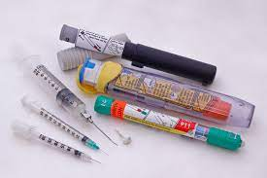
Assets for Sale | - P&M and Business Equipment - Goodwill / Trading Name  - Current WIP & Customer List (where applicable) - Domain name, Website, Digital/Social Media Assets
Further Information | Requests for further information should be addressed to Mark Rowlands of SIA Group. Contact details have been provided below.  Interested parties are invited to register their level of interest. Access to additional information will be provided on receipt of signed NDA. All offers to be supported by proof of funding.

For further information please contact:  Mark Rowlands – SIA Group  T. 07368 503984  E.mark.rowlands@sia-group.co.uk | 

